Baptism of the Lord (Year C)  Reading I: Isaiah 40:1-5, 9-11  Responsorial Psalm: 104:1b-2, 3-4, 24-25, 27-30  Reading II: Titus 2:11-14; 3:4-7  Gospel: Luke 3:15-16, 21-22  Readings may be found on the US Bishop’s website:  The Baptism of the Lord | USCCB | 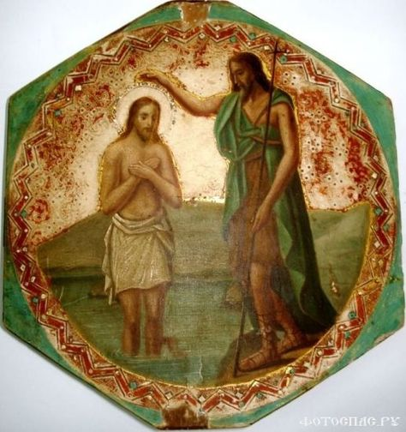
The Feast of the Baptism of the Lord concludes the Christmas cycle as Jesus begins his public ministry. It celebrates the theophany, the manifestation of Jesus to the world. His life before this had been hidden in the family life in Nazareth. Now, through the declaration of the Father, Jesus is revealed as the beloved Son of the Father.

The Gospel passage has two parts. It first clarifies whom John the Baptist is not and then presents in dramatic form, with a voice from heaven, who Jesus is. During the first century, there were many who looked to John as the great prophet from God. John baptized many of them and they followed the teachings of John. (St Paul encounters some Acts 19: 3 – 4) The Gospel writers identify John as not the messiah and that his baptism, even by his own admission, is only a sign of repentance. The baptism that the messiah, the greater one, will bring is one of Spirit and fire. Fire in the scriptures connotes cleansing. Fire separates impurities from the ore and produces authenticity. Spirit brings life. God breathed the breath (same word in Hebrew) into the first human and that person became a living being. Likewise, in Ezekiel God declares: “Dry bones, hear the word of the Lord! Thus says the Lord God to these bones: See! I will bring spirit into you that you may come to life.” (Ezekiel 37: 4b – 5) The fullness of this message will not be manifest until the coming of the Spirit in the Acts of the Apostles.

After Jesus was baptized like all the other people, he is at prayer. John’s action has been omitted further reinforcing John’s secondary role. The fact that Luke mentions all the other people introduces a theme that Luke will carry forward. Jesus will be with many people in many different situations throughout his ministry. He also introduces the importance of prayer.
There will be many occasions in the Gospel where Jesus spends time in prayer. This will be important for disciples as well.

Jesus was baptized not because of sinfulness, but as an act of obedience or submission to God, to be fully one with the human race. He fully accepts the mission to serve God in being the chosen one. While Jesus at prayer, the heavens were opened and the Holy Spirit descended upon him to anoint (messiah means anointed one) him to take up this mission. The proclamation from heaven is described so that all disciples may be confident that Jesus is the one sent by God. The “You are my son” is drawn from Psalm 2: 7 where the king of Israel declares that God has called him to lead the people. The words “with you I am well pleased” are connected to Is 42:1 (the reading used in cycle A). This is part of the first suffering servant song that describes how God’s servant will bring forth justice.

Baptism means to be immersed, to enter fully into something. For Christians, it is to enter fully into union with Jesus. Paul will describe it in Romans as dying with Christ and being raised to new life. (Rom 6: 3 – 4) In the Letter to the Galatians, Paul says, “I have been crucified with Christ; yet I live, no longer I, but Christ lives in me.” (Gal 2: 19b – 20) Baptism should manifest a profound reorientation of one’s life. One’s life should be orientated by the life and teaching of Jesus. One’s ego needs to be surrendered and placed in the service of God rather than in the advancement of one’s prestige and power. Like Jesus, baptism invites us to submit to God and respond to God’s invitations each day to be a disciple. As we open ourselves to God’s work within us, we experience being the beloved daughters and sons of the Father.

The first reading from Isaiah speaks about the great work that God will do in bring the captives back from Babylon. One does not need to fear for God is acting on your behalf. God will be like a shepherd, care for, and bring healing for each person. Jesus shows this in his ministry.

The reading from the Letter to Titus has two parts. The first speaks of the two comings of Christ. Christ came to be with us in his birth at Bethlehem and he will come again in glory. These two are linked and can only be understood in connection to each other. Christ came at Bethlehem to start the process that will lead to his return in kingship at the end of time. The second part of the reading speaks about the appearance of salvation. Christ came not simply to be with us but to save us. This salvation will lead to a regeneration, to the gift of new life, the life of God in us. Christ came that we too may become daughters and sons of God.

Key themes:
Sacrament of Baptism
Holy Spirit
Prayer
Conversion

Reflection questions:
How does baptism effect how you live? Or What impact do you hope your baptism will have in your life?

In what area do you need to change or be transformed by the Spirit?

How is the Holy Spirit making a difference in your life?

How and when do you pray? What are some of the experiences that you have had in prayer?

Prayer Suggestions:
For the Church: that we may recognize our calling to be daughters and sons of God and empowered by the Holy Spirit manifest God’s love and compassion through our words and deeds

For a renewal of the gift of the Holy Spirit: that God will stir up the gift of Spirit within us, make us strong in our faith and dynamic in love

For a deepening of prayer in our lives: that, like Jesus, we may grow in our relationship with God through prayer and listening

© Joseph Milner, 2022

